Rapid Evolution in the Presence of an Introduced Species Alters Community Composition and Network Structure

David Solance Smith*^{ab}, Matt K. Lauª, Ryan Jacobs^{a,} Jenna A. Monroy^{ab}, Stephen M. Shusterª and Thomas G. Whitham^{ac}

a Northern Arizona University, Department of Biology PO Box 5640, Flagstaff, AZ 86011-5640

b current address: Denison University, Department of Biology PO Box 810 Granville, OH 43023-0810

c Merriam-Powell Center for Environmental Research 800 S. Beaver PO Box 6077 Flagstaff, Arizona 86011-6077

* Corresponding author: current email: smithd@denison.edu Phone: (928) 221-7981

Abstract
It is becoming increasingly clear that evolutionary forces shape ecological patterns. Because several species often rely on a single foundation species, genetic variation and evolution of this foundation species will alter the surrounding community. These studies may help elucidate how introduced species alter native ecosystems. While introduced species are recognized as one of the biggest threats to native ecosystems, no study, to our knowledge has investigated an evolutionary mechanism by which introduced species alter native communities. Here, we use a common garden design to support two hypotheses. First introduced elk have caused the native plant, Solidago velutina to rapidly evolve. Plants originating from sites with introduced elk flowered nearly three weeks before plants originating from sites without elk. Second, plants originating from sites with introduced elk supported an arthropod community that had ~35% fewer total individuals, a different species composition and different interaction networks. Our results are important as they show that the impacts of introduced species may have both ecological and evolutionary consequences for strongly interacting species that subsequently cascade to affect a much larger community. Such evolutionary consequences are likely to be long-term and difficult to remediate.

Key words: community genetics, exotic species, genes to ecosystems, invasive species, plant-insect interaction, ungulate

Introduction
It is becoming increasingly clear that evolutionary forces shape ecological patterns. Several studies have shown that genetic variation in one species can shape species interactions and community composition (Whitham et al 2012 and references therein). For example, Bailey et al (2006) and Smith et al (2011) showed that individual genotypes of narrowleaf cottonwood (Populus angustifolia) support different densities of the galling aphid Pemphigus betae and different attack rates by birds on galls. In another study Keith et al (2010) showed that individual genotypes of P. angustifolia support unique compositions of arthropod communities and cottonwood genotypes differ in their stability through time. That is, while some genotypes supported relatively stable arthropod communities through time (relatively little change in community composition across years), other genotypes supported relatively unstable communities through time.
Knowing that individual genotypes uniquely influence communities, it follows that changes to the genotypic composition of a population (i.e. evolution) will further cause changes to communities.
A few studies examining species from different trophic levels, have shown that evolution of one species can influence community composition and ecosystem processes (Harmon et al 2009, Johnson et al 2009, Palkovacs and Post 2009, Bassar et al 2010, Agrawal et al 2012). In one example local adaptation of guppies (Poecilia reticulata) causes changes to community structure and ecosystem function. Across Trinidad, guppies experience one of two selection regimes by predators and hence have evolved into two ecotypes (Reznick et al. 1990, 1996). At low elevations, large predators are normally present that feed on larger guppies, causing local guppy populations to evolve, among other traits, a more predaceous diet compared to guppy populations in low predation environments (Bassar et al. 2010). Because guppies from high predation (HP) environments vary in their feeding strategies, their impact on local communities and ecosystem functioning also changes. Shown in both experimental and natural settings, HP guppies are more selective in their diets, consuming more invertebrates and less algae compared to their low predation (LP) counterparts (Palkovacs et al. 2009; Bassar et al. 2010). These dietary differences impact the local environment such that, in an experimental setting, mesocosms with HP guppies had higher algal standing stocks but had lower invertebrate biomass and benthic organic matter than mesocosms with LP guppies.
These studies may uncover one of the mechanism by which introduced species alter native communities. While introduced species are known to cause changes to native biodiversity (Coblentz 1978, Mooney and Cleland 2001), community composition and species interactions ((Christian 2001, Vazquez 2002, Sanders et al 2003) and cause native species to evolve (e.g. Vourc’h et al 2001, Callaway et al 2005, Strauss et al 2006, Lankau 2012).), no study to our knowledge has demonstrated how an introduced species causes evolution of a native species which then cascades to alter community composition. We investigated how rocky mountain elk (Cervus canadensis nelsoni), which were introduced to Northern Arizona ~80ya (Leopold 1918, Truett 1996), may be causing native goldenrod (Solidago velutina) to evolve and how this evolution alters the plant-associated arthropod community. Three previous findings led us to our hypotheses. Introduced ungulates are known to cause rapid evolution of plants (Vourc’h et al 2001). In addition, elk are known to forage on Solidago (Kufeld 1973), potentially causing plant populations to evolve. Finally, genetic variation in Solidago is known to influence the surrounding arthropod community (e.g. Maddox and Root 1987, Genung et al 2010, 2012). Thus, elk-induced evolution of Solidago could further change arthropod community dynamics. We use a common garden experiment to show two patterns: 1) S. velutina has evolved in the presence of introduced elk, and 2) the evolution of S. velutina alters the composition and network structure of the plant-associated arthropod community. Our results are important as they show that the community-level impacts of introduced species may have both ecological and evolutionary consequences for strongly interacting species that subsequently cascade to affect a much larger community. Such evolutionary consequences are likely to be long-term and difficult to correct or remediate.

Methods
Seed Collection and Common Garden
We collected seed from 73 individual S. velutina plants across six sites; three sites with relatively high elk densities and three sites with no measurable elk usage (Smith et al in review). To choose sites that lacked elk (but that did not differ in other environmental factors), we used two methods. First, we employed a method similar to Binkley et al (2006). For two elk-free sites we chose Solidago populations that were relatively close to human activity, which deterred elk usage without changing other environmental factors, such as precipitation and temperature that could affect plant traits (sensu Binkley et al 2006). For the third elk free site, we sampled inside a 30ha elk exclosure, erected in 2001 (7 years before this study), which experimentally excluded elk. To choose sites with elk, we chose a subset of the elk sites from a previous study (Smith et al in review) that were known to have high elk densities and that were well-spaced across the total sampling area (Smith et al in review) and included a site adjacent to the elk exclosure described above.
Once at the sites, we walked ~100m transects and collected seed from the first seed-bearing plant encountered.
To ensure that the 73 maternal plants (i.e. seed sources) were unique individuals, we collected seed from individuals that were at least 10m apart. In a previous study (Smith et al in review), we examined the root system of plants and never found clones larger than 2-3m in diameter. We collected seed in the late fall after all plants had flowered and set seed. Seed usually remains on plants for several months and up to a year (personal observation). Thus, by sampling after all plants had flowered and set seed but before any seed loss, we were not biasing our seed collection on plants with particular seed set time or seed retention abilities.
Seeds were placed in paper envelopes and stored at room temperature until the following February. Seeds from each mother were placed in plastic petric dishes in between two pieces of wetted filter paper (Whatman No. 1). Petri dishes were checked daily and watered as needed. Seeds took between one and three weeks to germinate. After three weeks, seedlings were transferred to potting soil in bookplanters (Tinus Roottrainers, Spencer-Lemaire, Edmonton, Alberta Canada), which were rearranged every two weeks to minimize microsite effects in the greenhouse
At the beginning of the second growing season plants were transplanted into 2L pots, which were filled with potting soil. In late spring, we transferred the plants to Hart Prairie Preserve (Nature Conservancy) north of Flagstaff, AZ USA, where they were placed inside an elk exclosure fence, within a natural population of S. velutina. Pots were arranged in a randomized design and watered as needed. In the late summer, when the plants began to flower, we measured the following traits on all flowering plants: i) Inflorescence size was measured as the number of florets per inflorescence. Some plants produced multiple inflorescences, in which case we used the average number of florets per inflorescence size in our analyses below. ii) For flowering phenology, we monitored plants two to three times per week and scored a plant as flowering when one half of the florets were completely open. We chose to score half the florets because not all florets will open (personal observation). iii) We also performed three arthropod surveys on each plant. Because it represents a resource for dozens of arthropod species (e.g. Genung et al 2010, 2012, Smith et al in review) and because many arthropods impact fitness of the plant, such as through pollination, we chose to survey the arthropods associated with the plant’s inflorescence. Two days after the plant was considered flowering, we performed the first of the three arthropod surveys. Subsequent surveys were performed every other day until surveys were completed. For each survey, we visually watched plants for five minutes and recorded all arthropods visiting the plant. We identified all arthropods to order, then as per previous studies (Oliver and Beattie 1996, Barbour et al 2009), we sorted arthropods to morphospecies based on external morphology. In total, we identified 44 morphospecies of arthropods from seven orders, including Diptera, Lepidoptera, Hymenoptera, Hemiptera, Thysanoptera, Coleoptera and Araneae.
Because we conducted our experiment during the second growing season, it is likely that maternal effects did not confound our results. Weis et al (1987) found that maternal effects in Solidago greatly decreased with time in a common environment. In their experiment, only two of the 17 traits (number and length of rhizomes) showed significant maternal effects, after the first growing season. Further, those maternal effects explained less than 10% of variation in plant traits. Of those traits that were measured, none showed significant maternal effects after the second growing season (Weis et al 1987). Because we conducted our experiment towards the end of the second growing season, maternal effects should have been minimized, if not completely eliminated.

Statistical Analysis
In the common garden, we used a linear mixed model to analyze flowering phenology and inflorescence size (number of florets per ramet). Because of non-normal distributions we used a generalized linear mixed model, with a quasi-Poisson distribution and log link function to analyze species richness and abundance. In both models, seedling family was nested within site, which was nested within the elk/no-elk gradient. Family and site were treated as random effects, while the presence/absence of elk was treated as a fixed effect. Lastly, because the focus of this paper was to examine the evolution of plant traits in the presence of elk, we only report the differences between plants from elk and no-elk treatment (see below). We used JMP to analyze the univariate response variables described above (JMP, Version 10. SAS Institute Inc., Cary, NC).
We used non-metric multidimenstional scaling (NMDS), perMANOVA and co-occurrence networks to examine differences in the arthropod community between the elk and no-elk sites. To graph and visually examine arthropod community structure, we used NMDS (McCune & Grace 2002). Before analyses, we removed species that appeared only once in the data set because a single occurrence of a species does not provide reliable information of group affinity (CITATION?). Additionally, we relativized abundances of each species by its maximum abundance to decrease the influence of extremely abundant species (McCune & Grace 2002). We then used a nested PerMANOVA (Anderson 2001) with Bray-Curtis distances to test for compositional differences of morphospecies and orders in the arthropod communities. Like the model for plant traits, plant family was nested within site, which was nested within the elk / no-elk gradient. The vegan package in R was used for the NMDS and PerMANOVA (Oksanen et al 2008).

NETWORKS
To exam co-occurrence patterns among the flower-associated arthropod species, we used Generalized Additive Models (GAM; Hastie and Tibshirani 1990) to model two networks: one for plants originating from sites with elk and another from sites without elk. To allow for the inclusion of morphospecies abundances, each network was constructed by assessing model fit of three possible GAM’s (gam package in R version 15.1.0 (Hastie 2011; R Development Core Team 2012) for each pairwise combination of species: 1) a “null” model with a constant slope, 2) a linear model and 3) a quadratic or hump-shaped model. The GAM with the largest Akaike weight was selected as the best fitting model (Burnham and Anderson 2002). If the “null” model was selected then the connection for that species pair was set to zero (i.e. there was no connection between that pair of species). The resulting network models were then analyzed for differences in the global structure of co-occurrence patterns. For weighted network statistics and plotting, we used the first-order term of each GAM to weight connections among species.

Results
Plant Traits
We found evidence that flowering phenology, but not infloresence size, evolved in the presence of introduced elk. Plants originating from sites with elk flowered nearly three weeks earlier than plants originating from no-elk sites (Fig 1a). Using June 1st as day 0, plants from no-elk sites flowered, on day 90 (August 30), whereas plants from elk sites flowered on day 71 (August 10; F_{1,3.593} = 11.69, p < 0.0317; Fig 1a). Somewhat surprisingly, inflorescence size in the common garden did not differ in the presence of elk (the average number of florets with elk = 42.4, without elk = 48.5; F_{1,19.21} = 0.0661, p=0.7998; Fig 1b).

Community Response
We found differences in total arthropod abundance, arthropod community composition and arthropod network structure on plants that originated from the presence and absence of elk. Arthropods were ~35% less abundant on plants originating from sites with elk (average abundance with elk = 20.7, without elk = 31.7, , X^{2 DF}= 61.62, p < 0.0001). Even though species richness did not differ between the two groups of plants (X² DF= 0.0974, p = 0.7550 ), community composition did differ across the elk / no-elk gradient (PerMANOVA for morphospecies: F_{1,4}= 3.29, p = .0065, Fig. 2). In using a linear mixed model described above to examine the most common morphospecies (gray beetle, aphids and ants), we found that aphids were ~2.5 more abundant on plants originating from sites without elk (Elk: 8.7, no-elk, 22.1; F_{1, 14.72} = 8.11, p = .0124).

Network Analysis
Some metrics show that the network structure of the arthropod community has changed in the presence of introduced elk. While the total number of connections in the network (i.e. the number of significant pairwise covariances) was similar between the two groups of plants (elk = 38, no elk = 35), there were changes to particular pairwise connections in the network (Fig 3). For example, on plants from sites without elk, arthropod13 (Gray Moth) was connected to (i.e. covaried with) 7 other species and arthropod16 (humpback fly) did not covary with other arthropods. Conversely, on plants from sites with elk, artrhropod13 did not covary with any other arthropod, while arthropod 13 covaried with three other arthropods (Fig 3).

what about fragmentation? (elk = 0.29, no elk = 0.35)

We also found that arthropod communities on no-elk plants were ~2.5x more centralized compared to the arthropod communities on elk plants (elk = .049, no elk = 0.099) Fig Centralization). INTERPRET: What does this mean?

Discussion
The data reported here adds to a growing number of studies showing that the evolution of one species can cause the surrounding community to change (Harmon et al 2009, Johnson et al 2009, Palkovacs and Post 2009, Bassar et al 2010). Further, this is the first to show this pattern with respect to an introduced species causing evolution in a native species and subsequent changes to the community. Previous studies have shown how introduced species can directly and indirectly alter communities via the removal of species (Vazquez 2002). Directly, introduced species can displace native species via consumption or competition (Huntly 1991 – from Vazquez review), which alters community composition. Introduced species can also indirectly alter communities (Wardle 2001, Christian 2001, Koh et al 2004). For example, when one species is obligately dependent on another, the local removal of one species can cause the other to be removed (Koh et al 2004). While these studies showed some ways by which introduced species alter native communities we know of no study that used a genetic perspective to show how introduced species alters community structure and species interactions (see Lankau and Strauss, Lankau 2012). Here, we showed that introduced elk caused the evolution of a single species which cascaded to alter local species composition and network structure of the plant-associated community. These results highlight the importance of intraspecific variation and an evolutionary perspective in understanding community dynamics (Bolnick et al 2011, Hendry et al 2011, Whitham et al 2012) after species introductions.

Introduced Ungulate Causes Rapid Evolution of a Native Plant
Our results are consistent with previous results showing that anthropogenic forces, such as climate change and introduced species can cause rapid evolution of plant traits (Vourc’h 2001, Callaway et al 2005, Franks et al 2007, Lankau 2012). Rocky Mountain Elk were introduced from Yellowstone National Park into parts of New Mexico and Arizona starting in the 1910’s and continuing through the 1950’s (Leopold 1918, Truett 1996). While a subspecies of elk (Merriam’s elk) was present in part of the southwest prior to this stocking, there is no record of Merriam’s elk in the San Francisco Peaks region of Arizona, where we conducted our study (Truett 1996). Thus, browsing by elk represents a relatively new selection pressure on S. velutina in Northern Arizona. Further, the elk exclosure used in this study was erected in 2001, only seven years before our seed collection. Thus the evolutionary change seen in this study occurred in ~50-80 years (after the elk introduction) and perhaps in as little as 7 years (response seen at exclosure). Ideally, our study design would have included multiple elk exclosures, which would have excluded elk while while keeping all other environmental variables the same between elk and no-elk sites. Despite this, evidence suggests that elk are the causative agent of genetic differentiation between elk and elk-free sites. One of our elk-free sites was an elk exclosure. Plant trait values and arthropod communities were not significantly different between the exclosure, where elk were experimentally excluded, and other sites where elk were naturally excluded (Fig 1b, Fig 2).
Our findings of evolution in flowering phenology are consistent with other studies showing rapid phenological shifts in response to anthropogenic factors. Franks et al (2007) showed that the populations of Brassica rapa evolved to flower ~8 days earlier (on average) to avoid the onset of drought conditions (i.e. climate cange). Further, this response was measured after just seven generations. In another example, McNeilly and Antonovics (1968) showed the evolution of phenology in two plant species, Agrostis tenuis and Anthoxanthum odoratum growing in soils polluted by mine tailings. Plants from polluted soils flowered several days to weeks before conspecifics growing in non-polluted soils. In the mine tailings example, it is thought that phenologies are diverging to inhibit gene flow between polluted and non-polluted populations to maintain adaptive traits in each population (McNeilly and Antonovics 1968). Considering these examples, phenological shifts seen in our study could have evolved especially rapidly due to two interacting factors. First, S. velutina may be flowering early to avoid herbivory (Pilson 2000). Elk in mountainous areas of Arizona are known to seasonally migrate along an elevational gradient, spending early summer at higher elevations (between 2400 and 2800m) and moving to lower elevations in the fall (Wallace and Krausman 1997). Our study was conducted at a relatively low elevation (~2100m), thus, it is possible that if plants flower before elk arrive in the fall, they may be able to sexually reproduce before being eaten. However, further experiments are required to determine if elk are directly or indirectly selecting on phenology (Weiss 1996, Franks and Weiss 2008). Second, phenology may have evolved to inhibit gene flow between populations with and without elk. If elk are indeed driving the adaptive evolution of traits, different flowering phenologies would inhibit gene flow between elk and elk-free populations and hence preserve adaptive trait values in populations that experience elk pressure (sensu McNeilly and Antonovics 1968)
Somewhat surprisingly, we did not find a difference in the inflorescence sizes of plants from elk and elk-free sites (Fig 1a). In a previous study, which examined plant traits across a natural range of elk densities and in and out of elk exclosures, S. velutina inflorescences were ~50% smaller in the presence of elk (Smith et al in review). However, in this study, which used a common garden approach, we did not find a difference in inflorescence size in plants originating from sites with and without elk. There are multiple possible reasons why plants would be smaller in the presence of elk, yet not evolve this same trait. Perhaps regular browsing by elk stunts plant growth without acting as an agent of selection on this plant trait. Another possibility is that inflorescence size is being selected on but is not evolving due to its (negative) correlation with other traits under selection (Weis 1996, Franks and Weiss 2008). For example, if phenology and inflorescence size are negatively correlated, such that early flowering plants are larger, selection on and evolution of early flowering plants would cause the evolution of larger plants even though they may be selectively disadvantageous. This highlights the importance of conducting common garden experiments, including the measurement of genetic correlations, to determine which traits are evolving to understand patterns of evolution.

Arthropod Community
We also found differences in the arthropod abundance, community composition and network structure on plants that originated from sites with and without elk. Overall, we found that plants originating in the presence of elk had ~35% fewer arthropods and a different composition of arthropod morphospecies. Because many of the observed arthropods were potential pollinators (e.g. Lepidopterans, Hymenopterans), it is possible that a shift in the arthropod community could further alter patterns of sexual reproduction and population genetic structure of this species. We also found that aphids were 2.5 less abundant on plants originating from sites with elk. This suggests that other unmeasured plant trait, such as chemical defenses, may also be evolving in response to elk introduction.

NETWORKS
The differences in networks between elk and no-elk plants suggest that arthropod interactions may be changing as a result of S. velutina evolution. Even though we did not explicitly examine them, network analysis has shown to accurately detect species interactions.
Tylianakis et al showed that networks can reflect species interactions (2007).
Assuming that the networks do reflect species interactions, these results suggest that invasive species are changing native interactions.
Interaction Biodiversity. “preserving a species interaction may be as important or even more important tha preserving the species itself. Elk greatly alter interactions such that even though a species is present both with and without elk, the interactions and the community it supports could be fundamental different.
Other studies have shown that species interactions can be contingent upon the presence or absence of other species (Strauss YEAR). Here, we show that a phenotypic change to one species (and not necessarily its addition or removal) can alter species interactions between other species. (but see Mooney and Agrawal paper)
While previous studies have examined the influence of evolved variation on community composition (Harmon et al 2009, Johnson et al 2009, Palkovacs and Post 2009, Bassar et al 2010), they have largely ignored the network structure, which describes patterns of the species co-occurrences and possible species interactions within the community (CITATIONS). Network structure helps to describe much of a community’s dynamics. For example, network structure has shown to influence community stability (Solé and Montoya 2001) energy flow (Tylianakis et al 2007), species coexistence and the maintenance of biodiversity (Bascompte et al 2006, Bastolla et al 2009). Tylianakis et al (2007) studied habitat modification via agricultural practices and its effects on herbivore-parasitoid communities. In their study, habitat modification did not change the richness or abundance of species, but it did change the patterns of species interactions and energy flow. In other words, conventional community metrics (richness and abundance) failed to discriminate among altered habitats, indicating that perturbations to the communities may be overlooked in studies that do not measure network structure (Tylianakis et al 2007).

Conclusions
Our study adds to a growing number of papers showing that the evolution of one species can alter the surrounding community (Harmon et al 2009, Johnson et al 2009, Palkovacs and Post 2009, Bassar et al 2010, Agrawal et al 2012, Lankau 2012). These results highlight the importance of the interaction of ecological and evolutionary forces in shaping patterns of species distribution, abundance and possibly species interactions. We suggest future studies consider an eco-evolutionary perspective when studying either evolution or community ecology. For example, Franks et al (2007, 2008) have used a resurrection design to detect evolution through time. In short, having collected seeds from previous time periods, they can “resurrect” populations from these previous times and compare them to current populations to look for evolutionary change in plants. If planted in a common garden, these resurrection studies could very easily examine how the focal plant interacts with and/or supports other community members and thus examine how evolution can also alter how the plant interacts with its biotic environment. Conversely, studies aimed at understanding patterns of community structure, such as after species introduction, include an evolutionary perspective by examining how genetic variation within species alters species interactions and subsequent community structure.

Acknowledgements
We thank B Blake and P Patterson at the NAU research greenhouse and the Nature Conservancy, especially Neil Chapman for their assistance in establishing the common garden. Special thanks to D. and L. Monroy Solance. Funding was provided by NSF FIBR grant (DEB-0425908) and an NSF IGERT to DSS.

Literature Cited
Agrawal, A. A. et al. 2012. Insect herbivores drive real-time ecological and evolutionary
change in plant populations. – Science 338: 113-116
Bascompte J (2009) Disentangling the web of life. Science 325: 416 – 419.

Bascompte J, Jordano P, Olesen J M (2006) Asymmetric coevolutionary networks
facilitate biodiversity maintenance. Science 312: 431 – 433.

Bassar, R.D. et al (2010) Local adaptation in Trinidadian guppies alters ecosystem
processs. Proc Natl Acad Sci USA 107: 3616-3621

Bastolla U, Fortuna M, Pascual-Garcia A, Ferrera A, Luque B, Bascompte J (2009) The
architecture of mutualisitic networks minimizes competition and increases biodiversity. Nature 458: 1018 – 1021.

Binkley D, Moore MM, Romme WH, Brown PM (2006) Was Aldo Leopold right about
the Kaibab deer herd? Ecosystems 9: 227 – 241.

Bolnick

Broker W (1963) Genetisch-physiologische Untersuchungen uber die Zinkvertraglichkeit
von Silene inflata Sm. Flora, Jena, 153: 122-156.

Burnham, K. P., and Anderson, D.R. (2002). Model Selection and Multimodel Inference:
A Practical Information-Theoretic Approach, 2nd ed. Springer-Verlag.

Callaway, RM, Ridenour, WM, Laboski T, Weir T, Vivanco JM (2005) Natural selection
for resistance to the allelopathic effects of invasive plants. J Ecol 93: 576-583

Collins, W.B, P.J. Urness and D.D. Austin 1978. Elk diets and activities on different
lodgepole pine habitat segments. The Journal of Wildlife Management 42:799-
810.
Franks SJ, Sim S, Weis AE (2007) Rapid evolution of flowering time by an annual plant
in response to a climate fluctuation. PNAS 104: 1278 – 1282.

Franks SJ, Weis AE (2008) A change in climate causes rapid evolution of multiple life-
history traits and their interactions in an annual plant. Journal of Evolutionary Biology 21: 1321-1334
Franks SJ, Avise JC, Bradshaw WE, Conner JK, Etterson JR, Mazer SJ, Shaw RG, Weis
AE (2008) The resurrection initiative: storing ancestral genotypes to capture
evolution in action. Bioscience 58: 870-873
Genung MA, Lessard JP, Brown CB, Bunn WA, Cregger MA, Reynolds WN, Felker-
Quinn E, Stevenson ML, Hartley AS, Crutsinger GM, Schweitzer JA, Bailey JK (2010) Non-additive effects of genotypic diversity affect pollinator visitation. PLoS ONE 5:e8711.
Genung MA, (2012)

Harmon LJ, Matthews B, Des Roches S, et al. 2009. Evolutionary diversification in
stickleback affects ecosystem functioning. Nature 458: 1167-1170.

Hastie, T. (2011) gam: Generalize Additive Models. R package version 1.06.2.

Hastie, T. J. and Tibshirani, R. J. (1990). Generalized Additive Models. Chapman &
Hall/CRC.

Hendry et al YEAR

Johnson, MTJ, Vellend M and Stinchcombe JR (2009) Evolution in plant populations
as a driver of ecological changes in arthropod communities. Phil Trans R Soc B 364: 1593 - 1605

Kufeld, R.C. 1973. Foods eaten by the rocky mountain elk. Journal of Range Management 26: 106-113.

Lankau, R. 2012 Coevolution between invasive and native plants driven by chemical
competition and soil biota. PNAS 109: 11240-11245

Leopold A. 1918 Restocking national forests with elk: where and how it may be done. In: Aldo Leopold’s Southwest ed.s Carmony NB, Brown DE 1995 University of New Mexico Press,

Maddox, G D and Root R B (1987)

McNeilly, T and Antonovics J (1968) Evolution in closely adjacent plant populations
IV. Barriers to gene flow. Heredity 23: 205-218.

Mooney HA and Cleland EE (2001) The evolutionary impact of invasive species. Proc
Natl Acad Sci USA 98: 5446-5451
Oksanen, J et al (2008). Vegan: community ecology package. R package version 1.15-1.
http://cran.r-project.org/, http://vegan.r-forge.r-project.org/
Palkovacs, E P and Post D M (2009) Experimental evidence that phenotypic
divergence in predators drives community divergence in prey. Ecology 90:
300-305

Pilson, D. (2000) Herbivory and natural selection on flowering phenology in wild
sunflower, Helianthus anuus. Oecologia 122: 72-82

R Development Core Team. (2012) R: A Language and Environment for Statistical
Computing. R Foundation for Statistical Computing. Vienna, Austria.

Rowntree J K, Shuker D M, Preziosi R F (2011) Forward from the crossroads of
ecology and evolution. Phil Trans R Soc B 366: 1322 – 1328.

Solé R V, Montoya J M (2001) Complexity and fragility in ecological networks (2001)
Proc R Soc London B 268: 2039 - 2045

Strauss S Y, Lau J A, Carroll S P (2006) Evolutionary responses of natives to
introduced species: what do introductions tell us about natural
communities? Ecol Lett 9: 357 – 374.

Truett, J. (1996) Bison and elk in the American Southwest: in search of the pristine.
Environ Manage 20: 195-206

Tylianakis JM, Tscharntke T, Lewis O T (2007) Habitat modification alers the
structure of tropical host-parasitoid food webs. Nature 445: 202 – 205.

Vazquez, D P 2002 Multiple effects of introduced mammalian herbivores in a
temperate forest. Biological Invasions 4: 175-191.

Vazquez D P and Simberloff D (2003) Changes in interaction biodiversity induced
by an introduced ungulate. Ecol Lett 6: 1077 – 1083.

Vourc’h, G., Martin, J.-L., Duncan, P., Escarré, J., and Clausen, T.P. (2001). Defensive
adaptations of Thuja plicata to ungulate browsing: a comparative study
between mainland and island populations. Oecologia 126: 84-93

Wallace MC and Krausman PR (1997) Movements and home-ranges of elk in Eastern
Arizona. Proceedings Deer/Elk Workshop – Arizona

Weis, A.E., Hollenbach, H.G. & Abrahamson, W.G. (1987). Genetic and maternal
effects on seedling characters of Solidago altissima (Compositae). Amer. J.
Bot., 74, 1476-1486.

Weis, AE 1996 Variable selection on Eurosta’s gall size, III: can an evolutionary
response to selection be detected? J Evolution Biol 9: 623 – 640.

Whitham, T. G. et al. 2012. Community specificity: life and afterlife effects of genes. –
Trends Plant Sci. 17: 271-281.

Wilcove (1998) Quantifying threats to imperiled species in the United States.
Bioscience 48: 607-615.

Solidago spp. tend to be self-incompatible (Gross and Werner 1983 – Ecological Monographs)a

Table 1.
*NOTE: This table used a nested linear mixed model, where family was a random effect and site and elk were fixed effects. Leaf number and Leaf area were data from 2009 (after one year) and the number of florets, plant height and phenology were from 2010 (after two years).

Trait | Site | Elk? | No-Elk/ Elk (values)
Number florets | F=1.2964 p=.3289 | F= .4435, p=.5189 | 42.4 (±7.5)  48.8(±5.8)
Plant Height | F=6.903, p=.0018 | F=3.9612, p=.0630 | 36.4(±1.3)  33.2(±1.0)
Flowering Phenology | F=2.594, p=.0902 | F=35.7581, p<.0001 | 91.0 (±2.6)  71.1(±2.0)
Leaf number | F=1.75, p=.1508 | F=6.36  p= .0143 | 10.9 (±1.0)  7.4 (±1.0)
Leaf Area | F=2.99  P=.0265 | F= 4.89  P=.0313 | 7.15 (±.29)  6.25 (±.28)

Fig 1.
Evolution of S. velutina in the presence of elk. There was no difference in inflorescence size (measured as the number of florets per inflorescence) in the presence of elk (A, p value?). However, we did find evidence that flowering phenology evolved. Plants originating from sites with ungulates flowered nearly three weeks early than plants originating from sites with no ungulates (B, p value?
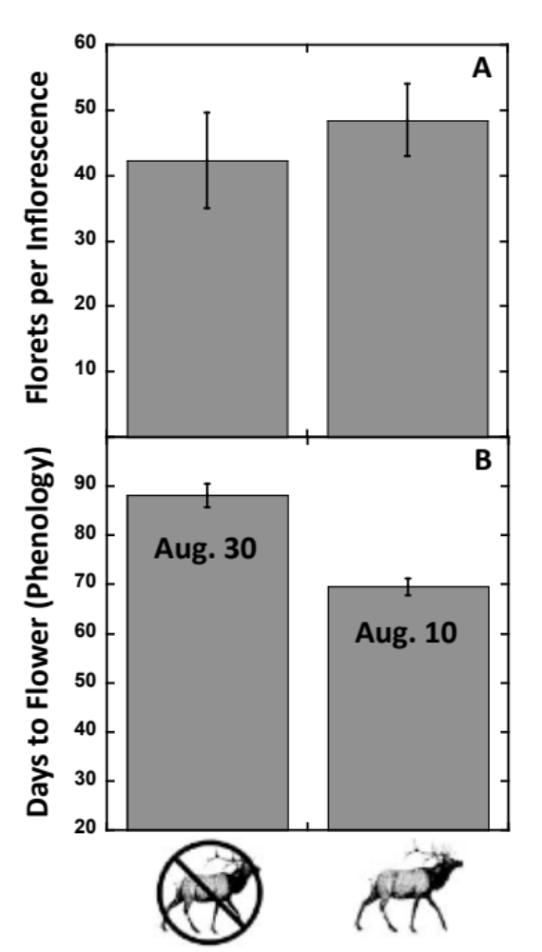

Fig 2. An NMDS plot of the arthropod communities on S. velutina that originated from sites with and without elk. Results from the perMANOVA (see Results section) show that plants originating from sites with elk (squares) supported a significantly different arthropod community than S. velutina originating from sites without elk (circles).

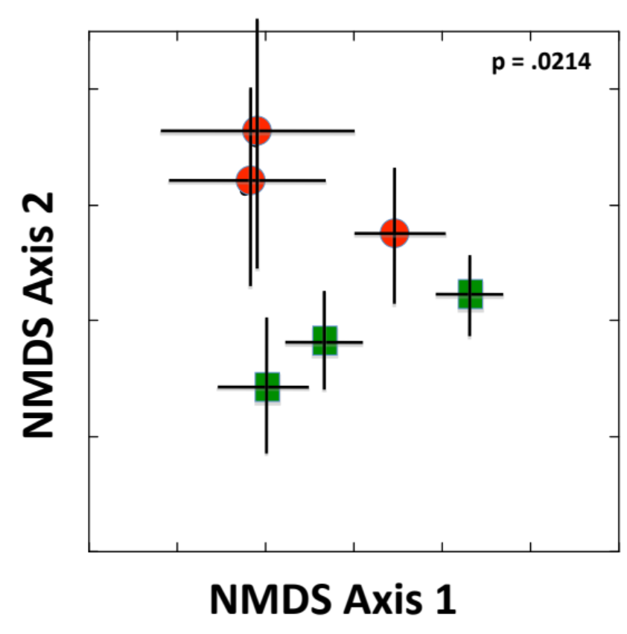

Fig 3. Network graphs of the arthropod communities on S. velutina collected from sites with and without elk.

